**Unit 11: Damped and Undamped Linear Systems**

Goals/Rationale

The mathematical goals of Unit 11 are for students to find and interpret solutions to linear systems of differential equations when the spring-mass phenomenon is damped and undamped (i.e., when the mass oscillates around the center until coming to rest, creating spiralling solutions and the idealized case when there is no friction). This happens mathematically when the eigenvectors and eigenvalues are complex. The basic idea is to use the same algebraic approach developed in the previous sequence, but now with complex numbers. This is a very difficult and symbolic sections where expectations are that students may need significant support from the teacher. However, it is important for the students mathematical development that the ideas of straight-line solutions (eigensolutions) be carried through even though the idea of the eigensolutions requires abstract thinking.

**Page 11.1-11.4**

Implementation Notes and Student Thinking

*Problems 1-6*

This set of problems could be done in several ways such as interactive lecture, or “you do one, I'll do one and then students present.” Or students could work in groups and stop after each problem to discuss or students could work on the problems and then the teacher could hand out or present solutions.

In the problems, the students are led through the development of the complex “straight line” solutions for the specific situation that the slopes of the imaginary straight line solutions are 1 $± i$. The process is the same as what they have already done for the real value slopes other than when they found straight line solutions but the quadratic they come to solve yields complex numbers for the slope. The complex numbers are used in the same way as when real numbers were slopes, but it does get messy and symbolically very detailed.

Below is the work for *Problems 1-6.*

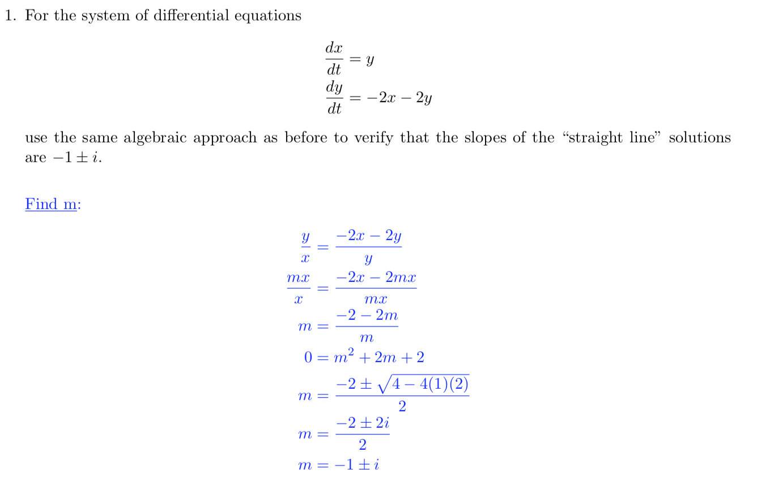

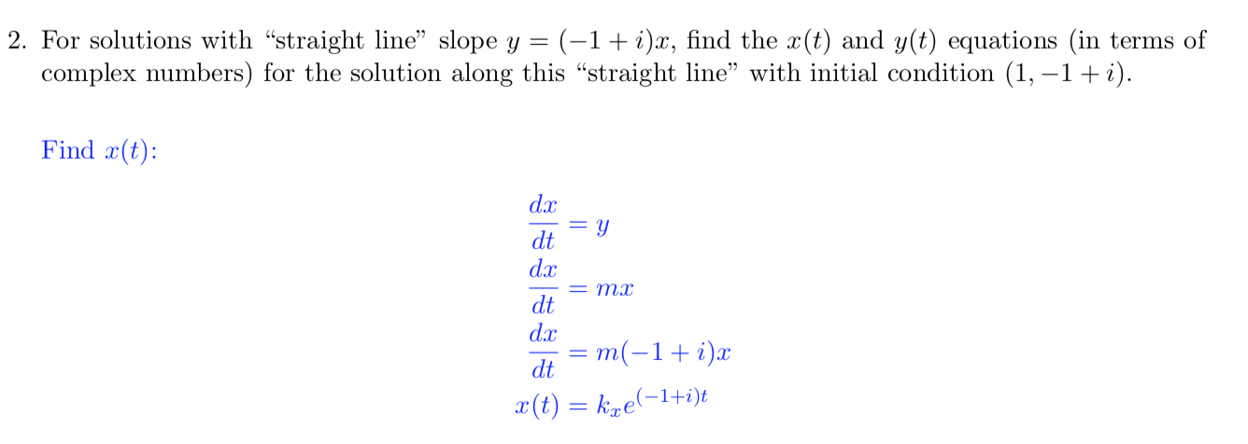

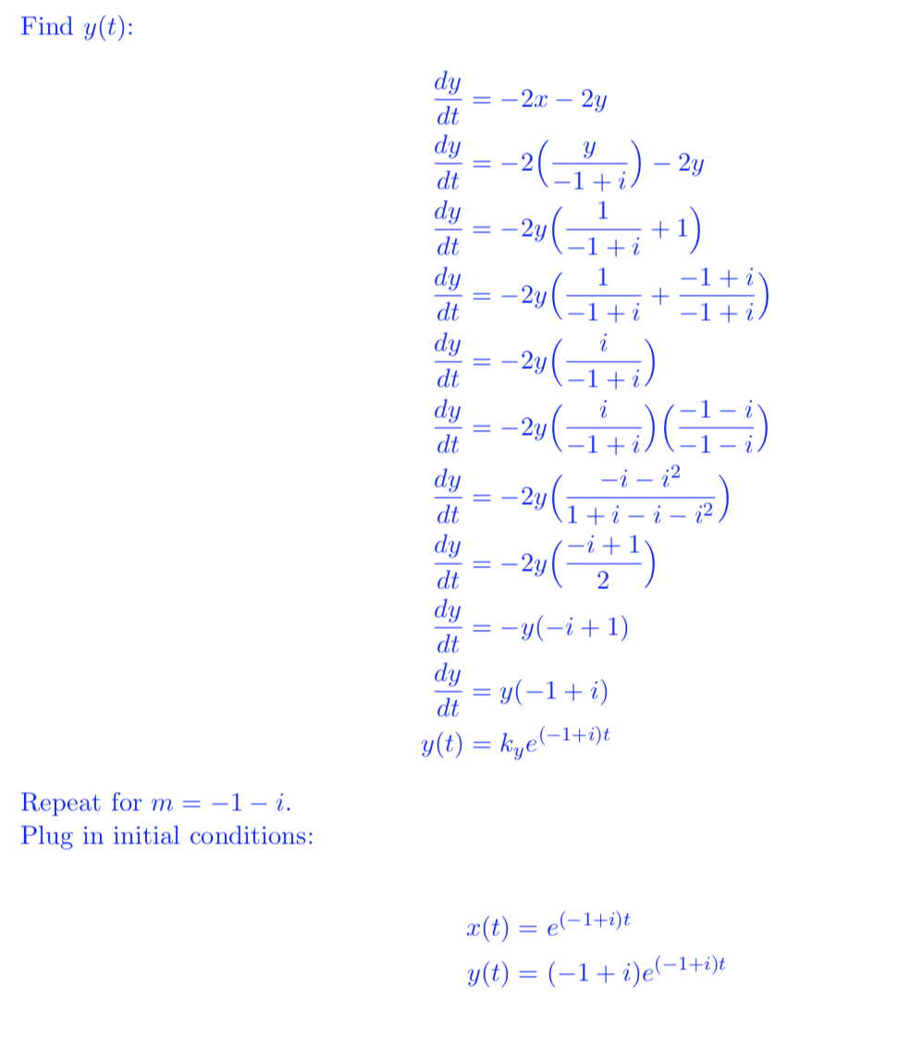

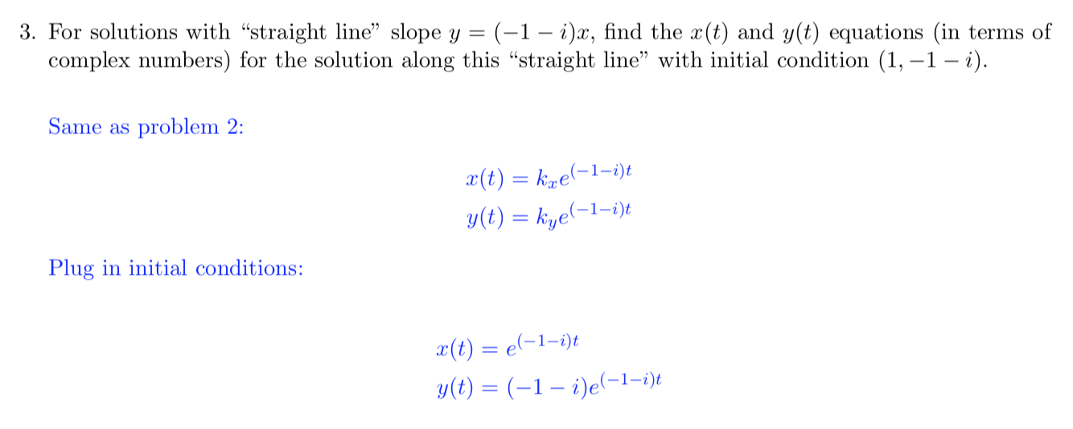

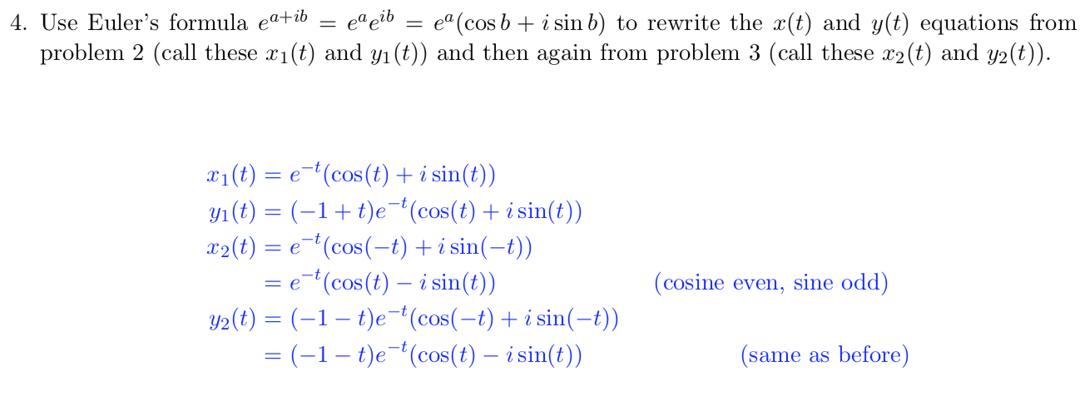

*Problem 5* - Students are exposed to and asked to think about a more formal justification of the earlier finding that adding two solutions results a solution. The intention is to generalize this result to any solutions to autonomous linear homogeneous systems of differential equations

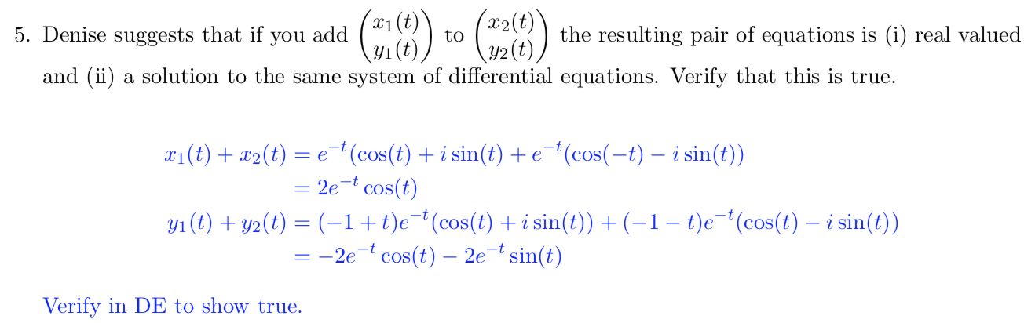

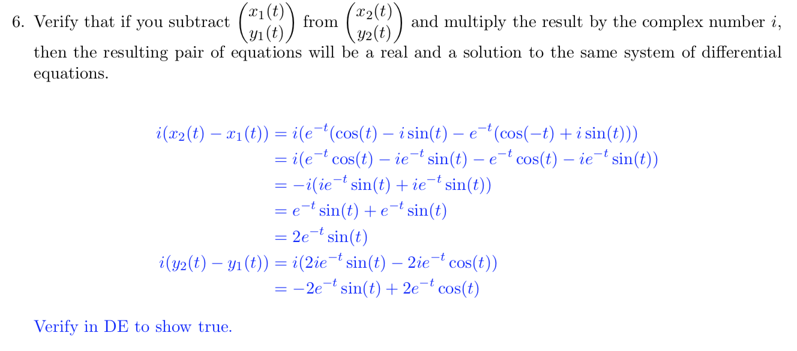

*Problem 7*

Students are asked to combine all the ideas from problems 1-6 to put together what the solution looks like. Students will find this difficult and the instructor may need to help with some of the general solution. In 7(b), the students should notice that the sine and cosine functions with the exponential function together create the idea of spiraling down to a point. 7(c) is important to continue to keep the conception of solutions as three dimensional curves at the forefront of the thinking. ______________________________________________________________________________

**Homework Problems**

The homework problems in this section are important to use and may be part of the in class work if that is what the instructor seems.

**Notes for Personal Reflections on Unit 11**